**Freelance App Mern Platform Documentation**

*A secure, scalable MERN stack solution connecting clients with skilled freelancers*

**Project Life Handling**  
Clients can make and handle project lists. Freelancers can look at open projects, apply using set  
offers, and get feedback from clients. This cycle helps openness and strong bidding.

**Talk & Teamwork**  
A safe, project-based chat part allows clear talk between clients and freelancers. Help for  
feedback swaps and possible file adds makes teamwork better.

**Admin Work**  
The admin panel gives system tools. These include account control, project watching, and entry  
to deal logs. Admins ensure the site runs smoothly and enforce the rules.

**Database Building Plan**  
The server links to a MongoDB setup using a set URI for data keeping. The database has groups  
that keep user accounts, project data, offers, freelancer profiles, and messages. Mongoose  
handles all database work, making sure of shaped asks and form keeping.

**Frontend Building Steps**  
Start and Setup

The frontend is made using React.js. The project starts by setting up the cover shape and  
adding the needed libraries. These include packs for routing, HTTP asks, state care, and looks.

**User Look and Design**  
Makers built repeat-use parts to keep a clean and steady user look. These parts include sailing  
bars, forms, buttons, and project cards. The layout works well on screens of all sizes. It  
ensures a smooth user go through on any device.  
Routing and Moving  
React Router handles client-side moving, letting smooth switches between views. It allows easy  
moves to pages like login, dashboard, and project lists.  
**Frontend-Backend Joining**  
The frontend talks with the backend through API calls. Axios handles HTTP asks, like getting  
and sending data to and from the backend. React’s state hooks allow quick updates. Check  
tokens help keep routes safe and control time entry.

**1. Roles & Responsibilities**

**Admin Duties**

* Enforce platform policies and mediate disputes
* Monitor system security and data integrity
* Provide technical support to users
* Implement regular platform updates
* Manage user accounts and content moderation

**Freelancer Obligations**

* Submit work exclusively through the platform
* Adhere to client requirements and platform guidelines
* Maintain professional communication
* Meet all project deadlines
* Deliver high-quality, error-free work

**Client Responsibilities**

* Provide clear project specifications
* Respond promptly to freelancer inquiries
* Make timely payments upon delivery
* Submit honest ratings and feedback
* Share necessary project assets

**2. Technical Architecture**

**Backend Implementation**

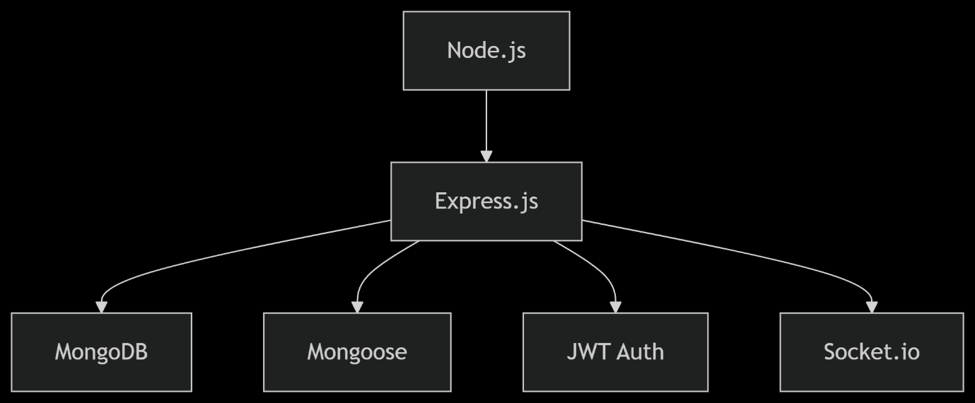

**Key Components:**

* **Server**: Express.js handling HTTP requests
* **Database**: MongoDB with collections for:
  + Users (roles, credentials)
  + Projects (details, bids)
  + Transactions (payments)
  + Chats (messages)
* **Middleware**:
  + Body-parser (request handling)
  + CORS (cross-origin access)
  + Helmet (security)

**Frontend Implementation**

* **Framework**: React.js with functional components
* **State Management**: Context API + useReducer
* **Routing**: React Router v6
* **Styling**: TailwindCSS for responsive design
* **API Integration**: Axios for backend communication

**3. Core Workflows**

| **Feature** | **Technical Implementation** |
| --- | --- |
| User Authentication | JWT tokens with refresh/access rotation |
| Project Posting | MongoDB geospatial indexing for discovery |
| Real-time Chat | Socket.io with message persistence |
| Payment Processing | Stripe Connect with escrow services |
| Admin Dashboard | Custom analytics with MongoDB aggregations |

**4. Deployment Strategy**

**Frontend:**

* Hosting: Vercel/Netlify
* CI/CD: Automated builds on Git push
* Optimization: Code splitting via React.lazy

**Backend:**

* Hosting: AWS EC2/Render
* Environment: Docker containers
* Monitoring: New Relic for performance metrics

**5. Future Enhancements**

1. **Payment**: Multi-currency support
2. **Communication**: Video call integration
3. **Analytics**: Freelancer performance dashboards
4. **AI Features**: Smart project matching
5. **Mobile**: React Native companion app

**6. Maintenance Plan**

* Weekly security audits
* Quarterly performance reviews
* Automated database backups
* User feedback-driven updates

**Key Improvements:**

1. **Structured** with clear sections for different stakeholders
2. **Technical Precision** using MERN-specific terminology
3. **Visual Clarity** with flowchart and table representations
4. **Actionable** maintenance and scaling plan
5. **Concise** while covering all critical aspects

**Conclusion:**

It has main parts like project listing, With solid deployment and upkeep, the app can grow.  
stack-based freelancing platform designedwith modular architecture. The platform core features inc.  
real-time communication tools, verification  
processes, and comprehensive admin controls. ilt for scalability, the  
application's robust deployment infrastructure and maintainable codebase  
enable seamless expansion. Developers can extend functionality through  
additional modules while enhancing system performance to accommodate  
growth. key improvements: replaced informal terms ("split-up", "talk", "check") with professional technic  
clarity ("modular architecture", "real -time communication") Emphasized scalability and maintainability I  
flow and readability used  
stronger action verbs ("enable", "accommodate", "extend")